**Day 1.**

**What is SDLC ?**

SDLC stands for software development life cycle

1. It is structured process and it used to plan, analysis, design, code,test,deploy and finally maintanance.
2. This process will improve the quality and this is cost effective process

**Task 2:**

**Why is SDLC ?**

SDLC Will improve the quality, cost effective, we can collaborate with different people and Maintenance will be easy that’s why We use SDLC.

**Task 3:**

What are the stages of SDLC ? write 2 lines about each?

There are seven stage of SDLC :

1.Planning Stage

2.Analysis stage

3.Design Stage

4.Code Stage

5.Test Stage

6.Deployment stage

7.Maintenance stage

* **Planning Stage** contains gathering the details form the user and gathering the details of project scope and scheduling it based on that.
* **Analysis Stage** is basically understating the user requirements based on that we need to execute the ideas
* **Design stage** developer understand the requirements and start designing it
* **Code stage** they will start write the code in computer language
* **Test stage** once the code is done the testing team will test the all the function are working as per the requirement
* **Deployment stage** once all the functions are working properly they will send the next phase they will install and work on it
* **Maintenance stage** fixing and updating it after deployment if any issue arrives

**Task 4 , 5 , 6**

List them , description - 4 lines min and with a image

**Waterfall model :**

This model is a linear software model where each phase must complete before next begains .

it is structured approached model

**Application** ; clear and well defined requirement (banking sector)

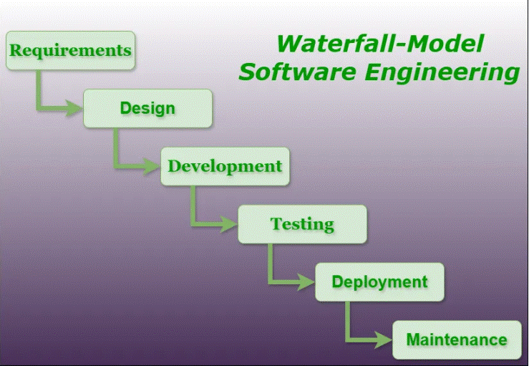

**Advantage** :

It is clear structure and easy to understand

**Disadvantage** :

Lack of flexibility and delayed in testing

**V- model :**

V- model will testing and validate each stage of development

This **application** in clear and stable requirements we use this model (Automotive )

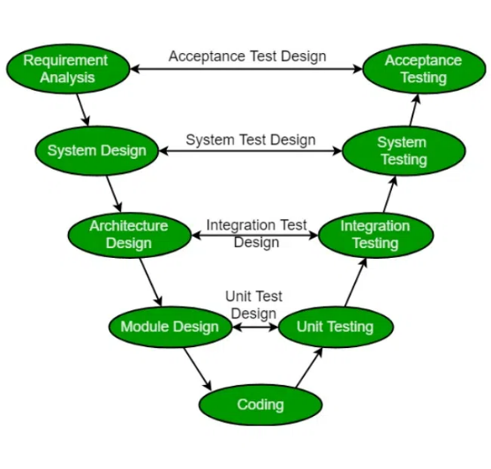

**Advantages:**

Parallel development and testing allow early defect identification and issues

**Disadvantage:**

Planning documenting and testing requires more time consuming

**Agile model:**

Agile model if flexible approach for changing requirements and finalizing complex projects

**Application** – projects with frequent change and requirements, feedbacks (web applications)

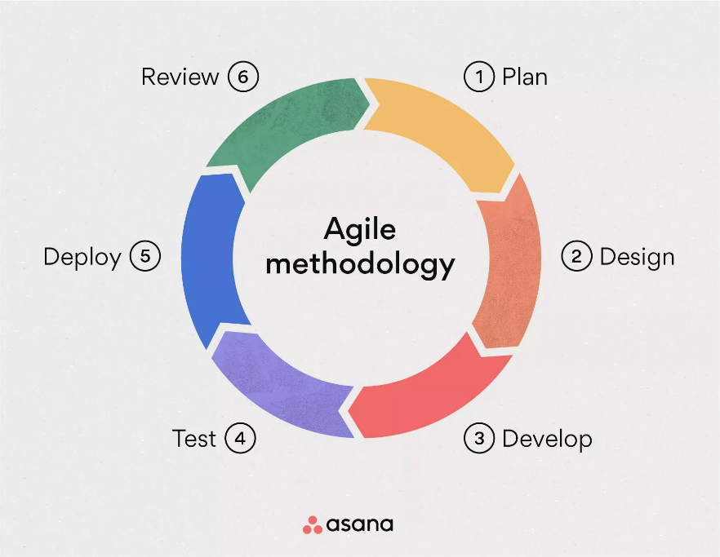

**Advantages :**

Customer Satisfaction

Continuous feedback and rapid delivery of working software ensure the product aligns with customer needs and expectations.

**Disadvantage :**

Challenges in Scaling

Scaling Agile practices across large organizations can be complex and require careful planning and implementation

**Iterative Model** involves repeating of design, development, and testing, allowing for improvements and adjustments asper the feedback.

**Application** : this model used contineous improvement and testing are important (E commerce platform)

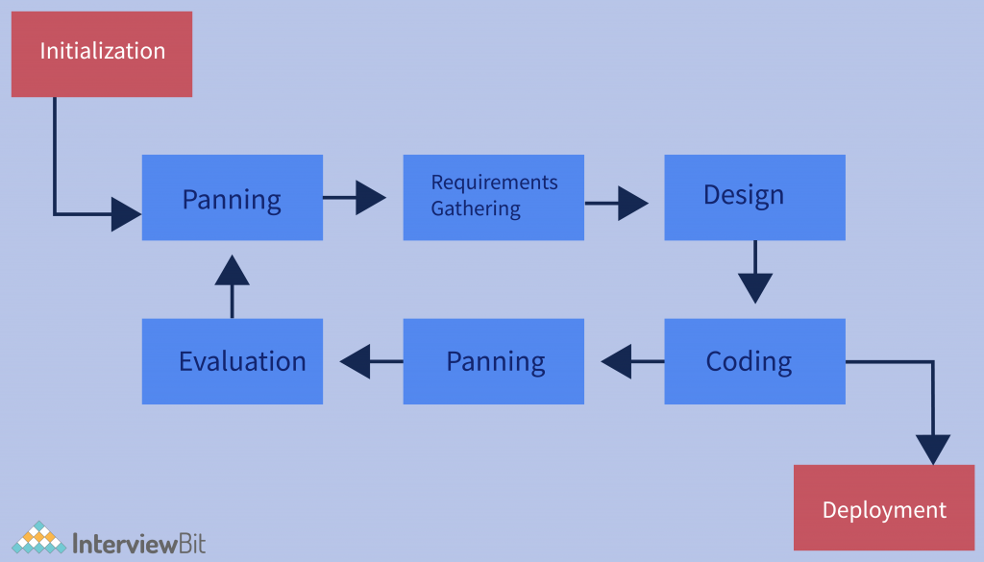

**Advantage:**

Early feedback

Working versions of the product are delivered early allows customer feedback early

**Disadvantage**:

This needs strong team and effective communication so dependency is required here.

**Spiral Model:**

Spiral Model is a combines elements of the Waterfall and Iterative models, addressing potential risks and adapting to changing requirements throughout the development cycle

**Application**: It required high risk and complex problems (Medical device software)

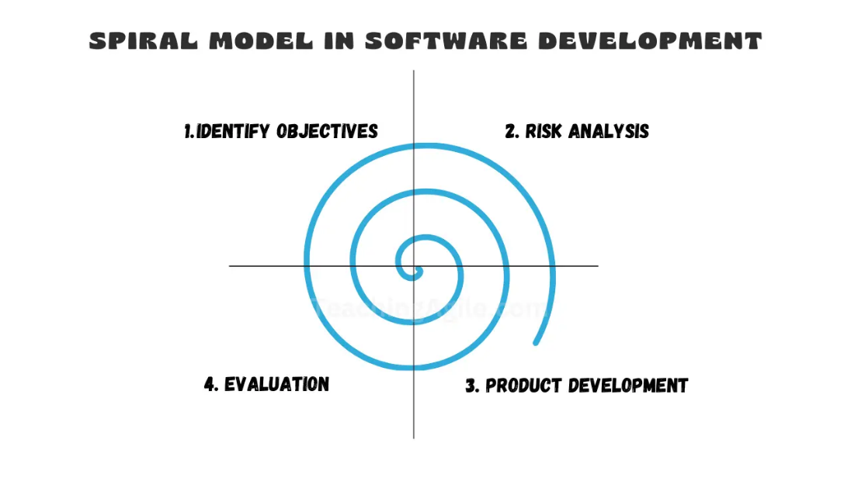

**Advantages and Disadvantages of spiral model**

**Advantage** – flexibility - This model allows changes and adjustment throughout the development process

**Disadvantage** –Multiple check can be time consuming and couldn’t able to complete it on deadlines.

**Task 7:**

**What do you understand by scrum?**

Scrum is a framework which commonly used in software development. It is self organizing the team to work together and organized the common goals.

it prescribes for teams to work into goals to be completed certain time

**Task 8:**

**what you meant by sprints?**

Teams can connect daily basics and update their status and breaking down the project and complete the task as per the time frames

(To do list and follow ups )

**Task 9:**

**what we need to do and don'ts while working on sprint ?**

**Do’s**

1. Prepare content
2. Set a meeting 10 to 15 mits
3. Discus with team about update
4. Review it with team

**Don’ts need to be follow**:

Don’t rush the planning

Don’t schedule too many connects

Don’t control the resources

**Task 10:**

**What is stories and backlogs :**

**Stories:**

A user story is a short, informal explanation of a end user

And it providing detailed descriptions of individual features.

**Backlogs** :

backlog is the roadmap of work, organized and prioritized by the team.

A backlog is a prioritized list of all the work needed to deliver a successful product.

**Task 11:**

**Scrum Artifacts**

**Product Backlog**

* **Sprint Backlog**
* **Burn-Down Chart**
* **Increment**

**Can you brief the above Artifacts.**

**Product Backlog** – it prioritized list of all the work that the team needs to do to deliver the product.  It's constantly being updated with new ideas, features, and bug fixes.

**Sprint Backlog** - This sprint backlog is a fixed time period for completing a defined amount of work

**Burndown Chart** - It is a visual representation of the progress made on a Sprint or project, helping to track work remaining and identify potential roadblocks.

**Increment** - The Increment is the result of a Sprint, containing all the completed Product Backlog items that meet the Definition of work.

**Task 12**

**What are Ports and Protocols?**

These are essential components that allows devices to communicate with each other over a network. (Like the internet or a local network )

**Port** is a logical access point for communication between your computer and other computer.

**Protocols** is a set of rules for how data is transmitted over a network.

**Task 13:**

**what are different types of networks ?**

LAN – Local area network ( connects small area)

PAN – Personal area neweork (works in personal space )

WAN – Wide are Network ( connects large area , connecting device with long distance)

VPN – Virtual private network ( secure connection crate a private network over public network)

SAN – Storage area network ( it give high speed access to storage areas)

**Task 14:**

**What are the types of servers ?**

**Make a list and write 2 to 3 liners about it.**

**web servers**- These servers host websites and web applications

**Database servers**- Dedicated to storing and managing data, often using database management systems

**Mail servers**- Handle the sending, receiving, and storing of email messages.

**File servers** - Provide centralized storage and sharing of files across a network.

**Application server**- Host and manage the execution of software applications, often acting as a bridge between users and back-end systems

**Task 15:**

**What do you know about DNS? Domain Name Service**

DNS (Domain Name System) distributed naming system for the internet that translates human-readable domain names (like www.example.com) into machine-readable IP addresses (like 192.0.2.1). This translation is essential for browsers and other internet applications to locate and connect to websites

Domain Name Service (DNS) acts as the "phonebook" of the internet, translating human-readable domain names (like google.com) into IP addresses (like 142.250.190.14) that computers use to communicate.

**Task 16:**

**what are the diffrent type network topologys?**

The most common types include **bus, star, ring, mesh, tree, and hybrid topologies**.

**Bus Topology**: All devices are connected to a single cable acting as a shared communication channel.

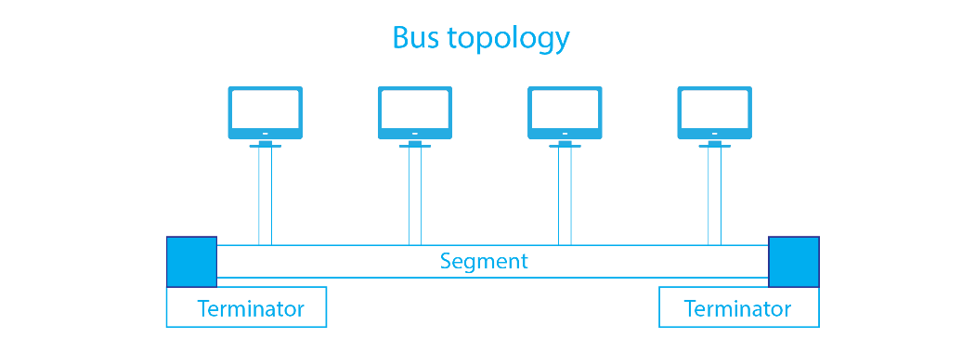

**Ring Topology**: Devices are connected in a circular fashion, with each device linked to its two neighbors.

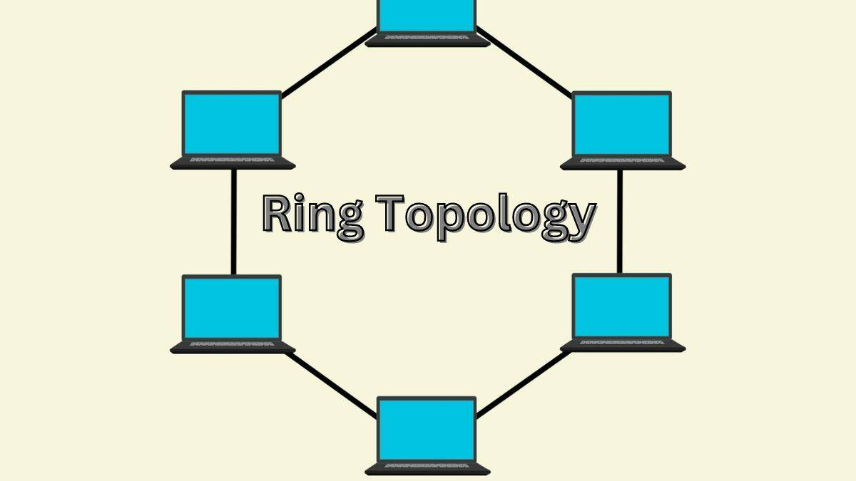

**Star Topology**: Devices are connected to a central hub or switch, making it easier to manage and Trouble shoot.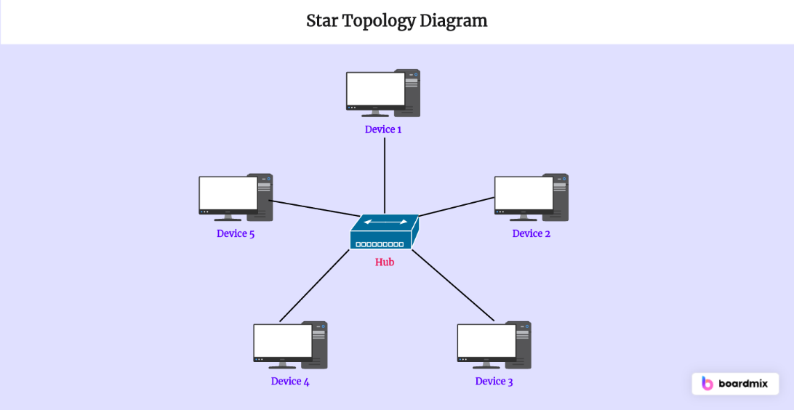.

**Point-to-Point Topology:** A direct connection between two devices, providing a dedicated and reliable pathway.  It is simple and cost effective , Not scalable

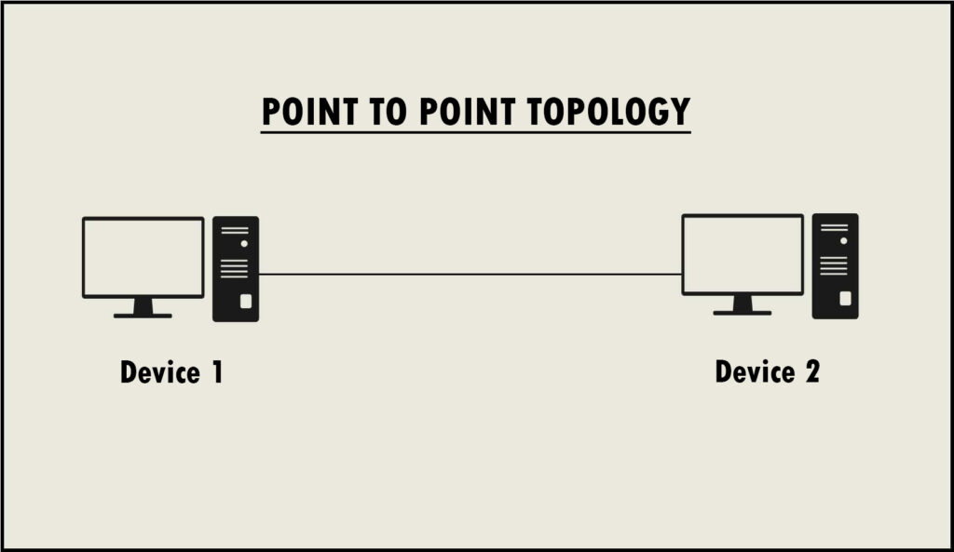

Task 17 :

What is OSI Model ?

Describe the 7 layers with description.

The Open Systems Interconnection model is a conceptual framework that describes how data communication occurs across a network, dividing it into seven layers.

1. **Physical Layer:** Deals with the physical transmission of bits across the network medium (e.g., wires, cables, wireless).
2. **Data Link Layer:** Responsible for data frame formation and error detection/correction within a single link.
3. **Network Layer:** Handles the routing of data packets across different networks, including IP addressing.
4. **Transport Layer:** Provides reliable and ordered delivery of data segments between applications, using protocols like TCP(Transmission Control Protocol ) and UDP(User Datagram Protocol).
5. **Session Layer:** Manages connections between applications, including authentication, authorization, and session establishment.
6. **Presentation Layer:** Handles data formatting, encryption, and compression.
7. **Application Layer:** Provides network services to applications, such as HTTP(HyperText Transfer Protocol) , FTP(File Transfer Protocol) and email.